CS 405 Project-1 Report

**TASK 1 AND TASK 2**

I started the project by looking and trying to understanding the code pieces, then like project pdf indicates I gave the files to chat gpt and it calculated the, TransformationMatrix for me even though I gave it to transformation-prompt.txt it misunderstood the assignment and calculated the numbers with respect to

Scaling -> Translation -> Rotation at first sight I did not understand that chat gpt did that way and I got following result this result is wrong since chatgpt did not understand the order

metin, ekran görüntüsü, yazılım, multimedya yazılımı içeren bir resim

Açıklama otomatik olarak oluşturulduekran görüntüsü, tasarım içeren bir resim

Açıklama otomatik olarak oluşturuldu

At first I thought this was right so kept going and started to the

Task 2,

I tried to understand the question and I asked questions to chat gpt about then chat gpt replied then chatgpt immediately said that you should start with Scaling so I understand something wrong and I asked that should not we start with Translation since the teacher asks that way it change it and I run the code so I get a following result ekran görüntüsü, tasarım içeren bir resim

Açıklama otomatik olarak oluşturuldu

This was way different that the Task1 so I understand that something is wrong so I asked chat gpt again   
metin, ekran görüntüsü, yazı tipi içeren bir resim

Açıklama otomatik olarak oluşturuldu

Then chat gpt understand that he did the Task1 with wrong order so actually Task2 image was right however Task1 was wrong when I understood that the situation I told chat Gpt to recalculate the Task 1 with the Translation -> Scaling -> Rotation so when it that way it gave result as

metin, ekran görüntüsü, yazılım, multimedya yazılımı içeren bir resim

Açıklama otomatik olarak oluşturuldu

As you can see transformationMatrix slightly changed so I re run the code with that matrix for task 1 and I get the following image result

Which was the same result as Task 2 so I understand that way there was little problem about the order of the matrix multiplications and I saw that it can lead a huge problem

Then I realized that the shape should not be like that so I asked chat gpt about it so I finally find a piece

ekran görüntüsü, grafik, tasarım içeren bir resim

Açıklama otomatik olarak oluşturuldu

**TASK 3**

I asked chat gpt to create a motion like the pdf indicates and it gave me the following code

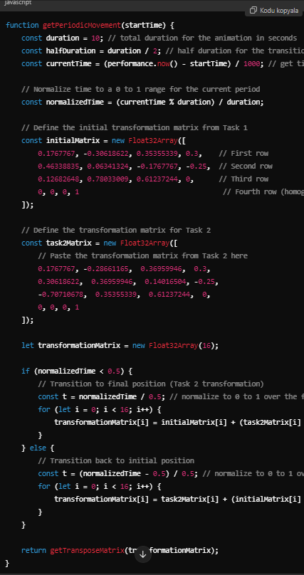

And its also working but it did not work also so asked chat gpt sometings to change its also in the chat gpt and I figure out something else

ekran görüntüsü, dikdörtgen, tasarım içeren bir resim

Açıklama otomatik olarak oluşturuldu  
  
now it properly rotates  
  
The chat that I did with the ChatGPT link is following:  
  
https://chatgpt.com/share/670a527d-1a9c-800a-9043-f54539de3600  
  
github CS 405 link is following:

https://github.com/tekinserhat/CS-405